How to Use This Flipbook

Use this flipbook as a tool to educate your community about Ebola. The words in bold are intended to be read aloud exactly as written. The additional information on each page is provided to help you better understand the topic and explain it in a way that is meaningful, accurate, and easy for your community to understand.

Review each page before presenting to a group so that your presentation goes smoothly. By understanding the signs, symptoms, transmission, and prevention of Ebola, you can help protect your community and reduce the spread of fear and misinformation.

This flipbook has been designed for easy translation into any language or local dialect. After completing your translation and reviewing the content for accuracy, save the document as a PDF before printing or distributing it. Saving the file as a PDF helps preserve the layout, images, and formatting.

Important Printing Information
This version of the document is not arranged in presentation order. It has been formatted in a print sequence so that, when printed double-sided and bound, the pages will appear in the correct order for use as a field flipbook.
Before printing:
• Verify that duplex (double-sided) printing and flip on long side is selected.
• Review the PDF to ensure the pages are aligned correctly.
• Print a test copy before producing multiple copies.
• Bind the flipbook along the top edge using spiral binding, comb binding, wire binding, or binder rings.

Important: Do not include this instruction page in the final binding of the flipbook.



www.ultimatemission.org
Disclaimer: The educational materials provided by Ultimate Mission are intended for informational and community education purposes only. They are not a substitute for professional medical advice, diagnosis, treatment, or official public health guidance. Churches, Healthy Heart workers and volunteers should follow all applicable regulations and guidance issued by local health authorities, ministries of health, the World Health Organization, and other authorized public health agencies.
References
- Shapshak P, Balaji S, Kangueane P, Kuhn JH, Somboonwit C, Sinnott JT, editors. Global Virology V: 21st Century Vaccines and Viruses. Springer Nature; 2025 Jul 11.
- Lee JS, Adhikari NK, Kwon HY, Teo K, Siemieniuk R, Lamontagne F, Chan A, Mishra S, Murthy S, Kiiza P, Hajek J. Anti-Ebola therapy for patients with Ebola virus disease: a systematic review. BMC infectious diseases. 2019 May 2;19(1):376.
- Mohanty A, Sharma S, Shubham, Mehta R, Srivastava S, Sah R, Rath RS, Rodriguez-Morales AJ. Viral Hemorrhagic Fevers in the Context of Global Health and Climate Change. InGlobal Health, Climate Change, and Emerging Infectious Diseases 2026 May 1 (pp. 135-158). Cham: Springer Nature Switzerland.
- Redding DW, Atkinson PM, Cunningham AA, Lo Iacono G, Moses LM, Wood JL, Jones KE. Impacts of environmental and socio-economic factors on emergence and epidemic potential of Ebola in Africa. Nature Communications. 2019 Oct 15;10(1):4531.
- Mergenthaler C, van den Broek A, Tromp N, Nehal K, Janssen J, Wang S, Samba TT, Vandhi M, Kombo AA, Sankoh O, Kamara MK. Feasibility and challenges in sustaining a community-based surveillance system in post-Ebola Sierra Leone. Conflict and Health. 2024 Nov 10;18(1):69.
- Kikwango EM, Akilimali PZ, Tran NT. Impact of most promising Ebola therapies on survival: a secondary analysis during the tenth outbreak in the Democratic Republic of Congo. Virology Journal. 2025 May 15;22(1):144.

Community Preparedness During an Ebola Outbreak 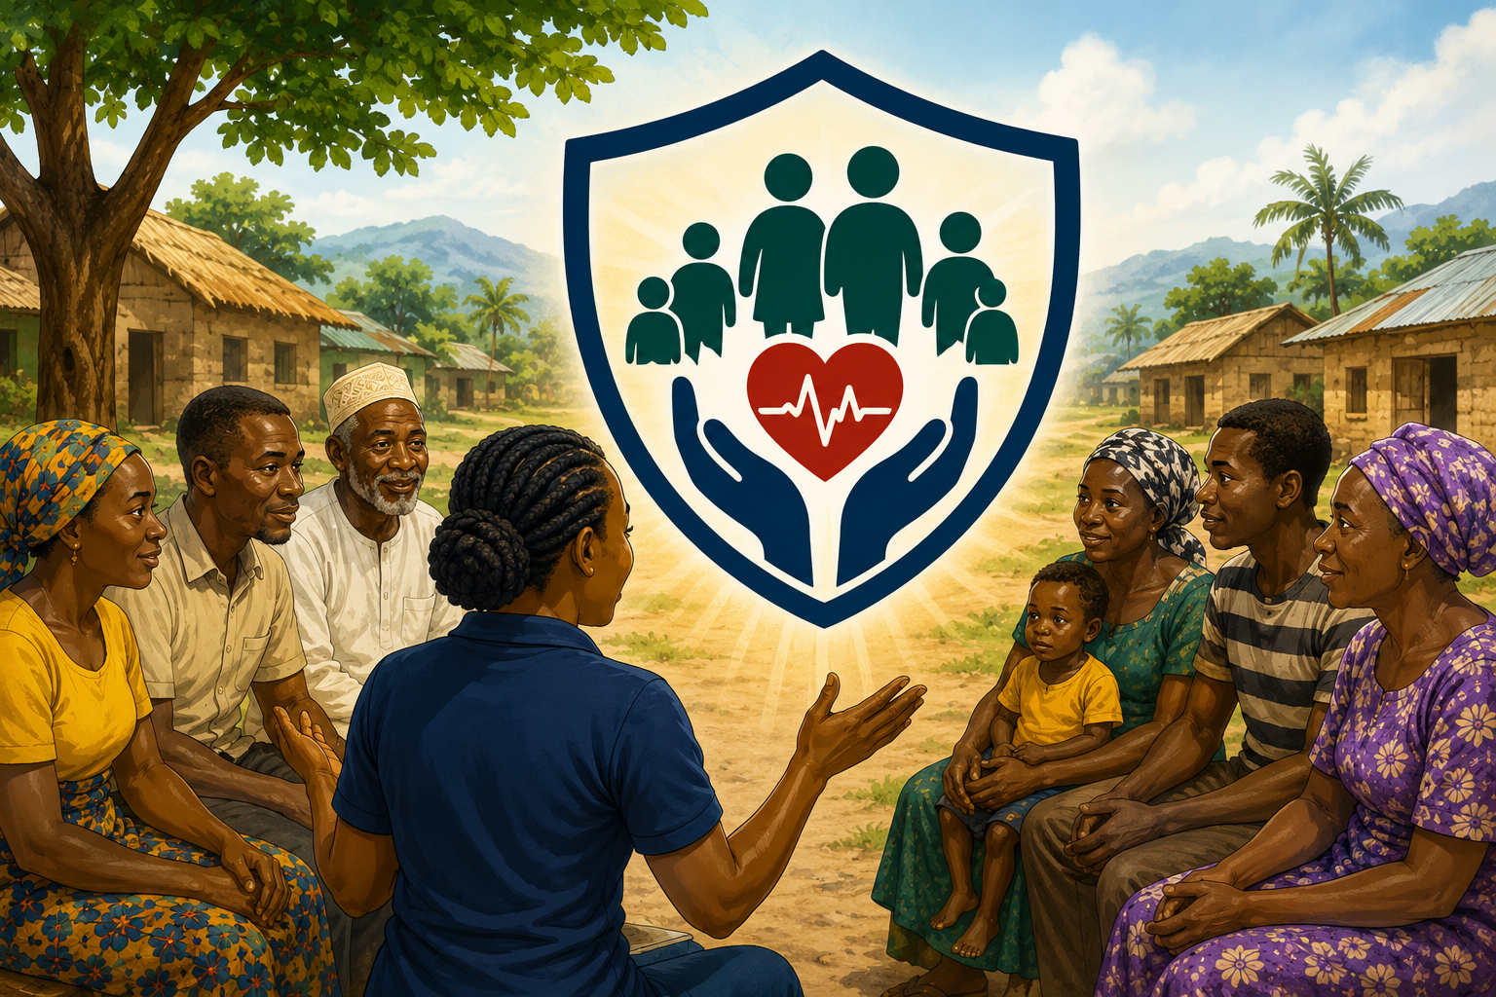

Presenter Notes: Review & Questions
This is a time for you to review what was learned and make sure everyone feels confident about the information. Allow several people to answer and as they respond, briefly review the major points from the lesson.
Here are questions you can ask as review:
"What is one new thing you learned today?"
“What is Ebola?
"What body fluids can spread Ebola?"
Remind participants:
"Ebola does NOT spread through air alone, talking from a distance, or mosquito bites."
"What are some common symptoms of Ebola?"
Remind participants that many illnesses such as malaria, typhoid, and flu can look similar at first.
"What are some ways we can protect ourselves and our families?"
"What should we do if someone is showing symptoms of Ebola?"
"How can we help our community during an outbreak?"
Remind participants that rumors create fear. Facts create safety. When we share accurate information, report illness early, and work together with health workers, we help protect our families and our communities.
Invite participants to ask any remaining questions.
Encourage discussion and clarify any misunderstandings.
If someone asks a question you do not know the answer to, be honest and encourage them to seek guidance from local health authorities or trained health workers.

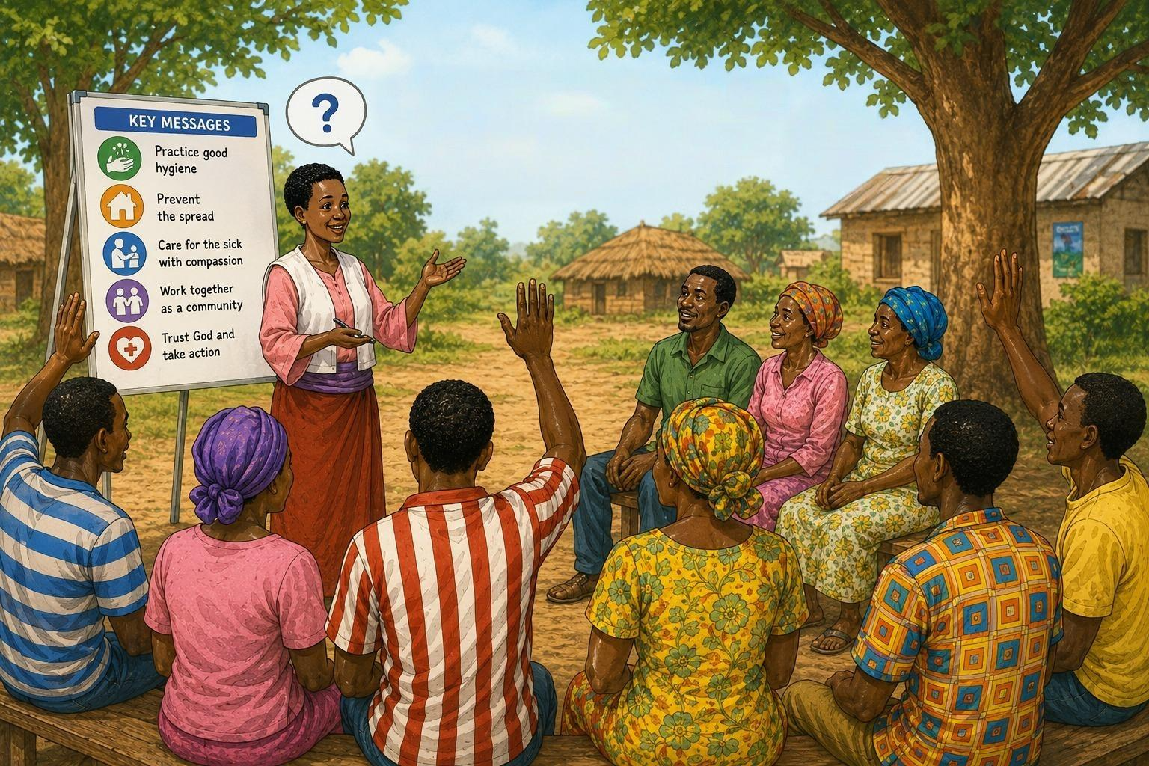

Presenter Notes: Spiritual & Emotional Encouragement (Optional)
Prayer is powerful, but prayer should also be accompanied by action.
- Sharing accurate information
- Encouraging early reporting of illness
- Supporting affected families
- Following safety precautions
- Helping our communities remain calm
Discussion Question
Ask:
"Why is it important to have both prayer and practical action during an outbreak?"
Allow participants to discuss.
Key Teaching Points
- Caring for others reflects the love of Jesus.
- Fear should not prevent compassion.
- Compassion must be combined with wisdom and safety.
- Prayer and practical action work together.
- Healthy Heart workers can be a source of hope, calm, and encouragement during difficult times.
Closing Thought
During an Ebola outbreak, people need more than information. They need hope.
By sharing accurate information, showing compassion, following safety precautions, and trusting God, we can help protect our communities and reflect the love of Jesus to those who need it most.

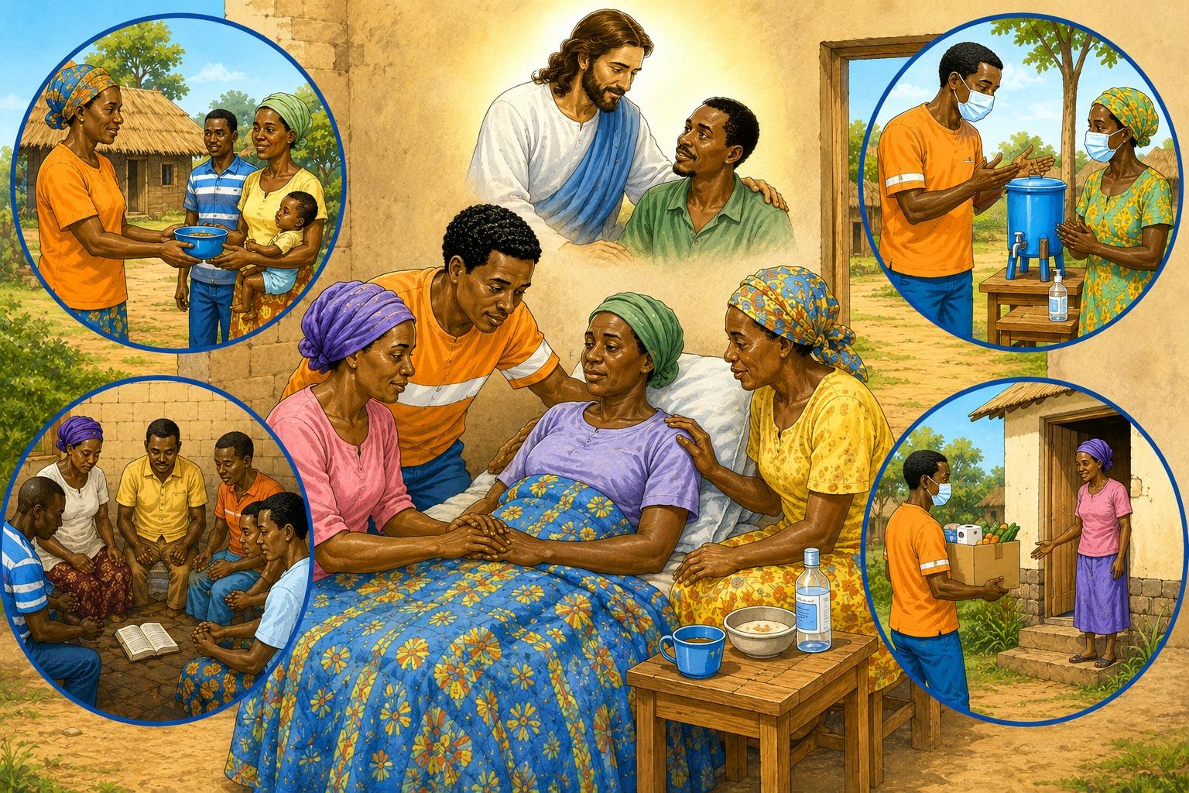

Presenter Notes: Spiritual & Emotional Encouragement (Optional)
As we come to the end of our lesson, it is important to remember that Ebola is not only a physical illness. Outbreaks can also bring fear, sadness, loneliness, and worry to individuals, families, and entire communities.
As Healthy Heart workers, we can help meet both physical and emotional needs.
Point to the image of caring for others.
Throughout His ministry, Jesus showed compassion to people who were sick, suffering, or rejected by others. He treated every person with dignity and love.
When we show kindness, encouragement, and concern for those who are suffering, we reflect the love of Jesus in practical ways.
Ask the group:
"What are some ways we can show kindness to a family affected by illness?"
Allow participants to share ideas.
Point to the image showing prayer.
Fear should not stop compassion.
This does not mean taking unnecessary risks or ignoring safety guidelines. We should never place ourselves or others in danger. Instead, we can show compassion in safe and appropriate ways.
We can offer encouragement, pray for families, help provide food and supplies, share accurate information, and support health workers who are caring for the sick.
Point to the image showing handwashing and safe practices.
Wisdom and caution are important.
God asks us to care for one another, but He also expects us to use wisdom. Following health guidelines, practicing good hygiene, and listening to trained health authorities are ways we protect ourselves and our communities.
Faith and wisdom work together.

Presenter Notes: Stigma Prevention
Important Teaching Points
- Fear should never become discrimination.
- Families affected by Ebola should not be rejected or shunned.
- Survivors deserve dignity, respect, and acceptance.
- Communities are stronger when they support one another.
- We can follow safety precautions while still showing kindness and compassion.
Discussion Questions
- What are some ways we can support a family during an outbreak?
- How can we help prevent rumors and discrimination?
- What can we do to help survivors feel welcomed back into the community?
Closing Thought
Ebola can separate people physically for a time, but it should never separate us in our hearts.
A strong community is one that protects its people, supports its families, welcomes its survivors, and continues to show the love and compassion of Jesus even during difficult times.

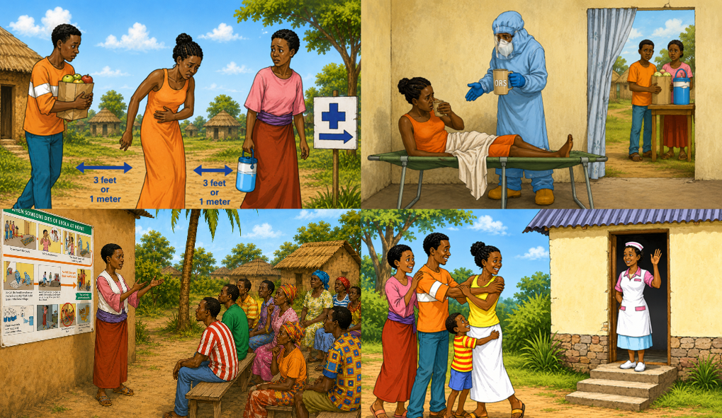

Presenter Notes: Stigma Prevention
As we have learned, Ebola is a serious disease. During an outbreak, people may become afraid for themselves and their families. While it is important to take precautions, we must be careful not to let fear cause us to treat others unfairly.
Point to the first image.
One of the greatest strengths a community can have during an outbreak is unity. When people work together, share accurate information, and support one another, they are better able to protect everyone.
Healthy Heart workers can help bring people together instead of allowing fear to divide them.
Point to the second image
Families affected by Ebola may already be experiencing stress, worry, and loss. They need encouragement and support from their community.
This does not mean ignoring safety guidelines. We can follow health recommendations while still showing kindness. We can pray for families, help provide food and supplies, check on them from a safe distance, and offer encouragement.
Point to the image showing community education.
Communities that understand the facts about Ebola are less likely to respond with fear. Education helps people replace rumors with truth and compassion.
Point to the image showing a survivor being welcomed.
People who recover from Ebola deserve dignity and respect. A person who has recovered and has been cleared by health authorities should not be treated as an outcast.
Survivors are often strong members of the community who have been through a very difficult experience. They need friendship, acceptance, and encouragement as they return to normal life.
Ask the group: "How would you want others to treat you or your family if you had been sick?"
Allow participants time to discuss.

Presenter Notes: Community Protection Roles

You and I are not trained to care for someone with Ebola, but that does not mean we cannot help. Every one of us has a role to play in preventing the spread of this virus.
Parents – Stay calm and teach your family how to recognize the signs and symptoms of Ebola and who to contact if someone becomes ill. Practice and model good hygiene habits every day.
Teachers – Stay calm and teach your students the importance of good hygiene. Help them understand that even children can save lives by recognizing the signs and symptoms of Ebola and knowing when and how to seek help.
Children – Stay calm and learn the signs and symptoms of Ebola. Practice good hygiene habits, know who to call for help, and respectfully speak up if you see something that could put others at risk.
Community Leaders – Stay calm and share accurate information with your community in a timely manner. Help stop the spread of rumors and misinformation about Ebola. Develop an emergency response plan so your village knows what to do if someone begins showing signs and symptoms of the disease.
Religious Leaders – Pray daily for wisdom, protection, and guidance. Stay calm and provide accurate information to those in your care. Help dispel myths and fears about Ebola, and have a plan in place to respond appropriately if someone comes to you with concerns or possible symptoms.

Everyone has a part to play in keeping their community safe. Remind them that what they do and say is important.

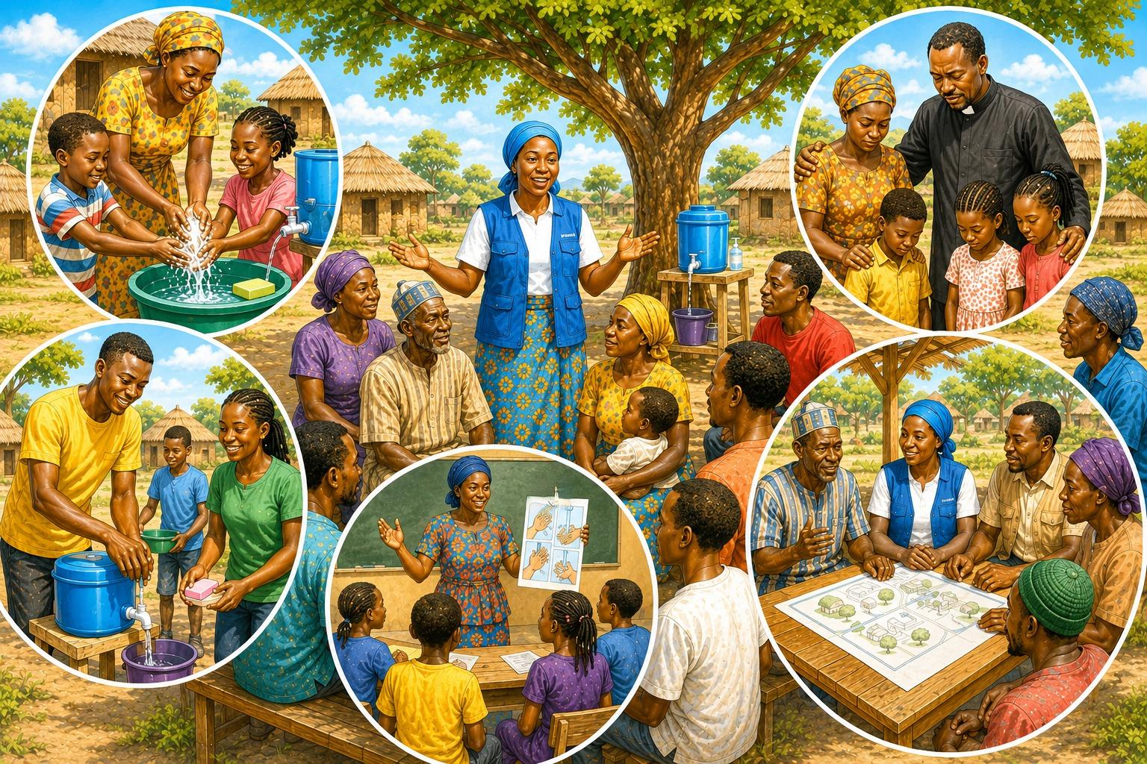

Presenter Notes: Myths and Rumors About Ebola
Remind participants:
"Just because many people believe something does not make it true."
Group Activity
For each picture, ask:
- Is this a fact or a rumor?
- How could believing this rumor put people at risk?
- What is the correct information?
Allow participants to discuss before reviewing the answer together.
Closing Thought
Rumors create fear. Facts create safety.
When we share accurate information, report illness early, and work together with health workers, we help protect our families and our communities.

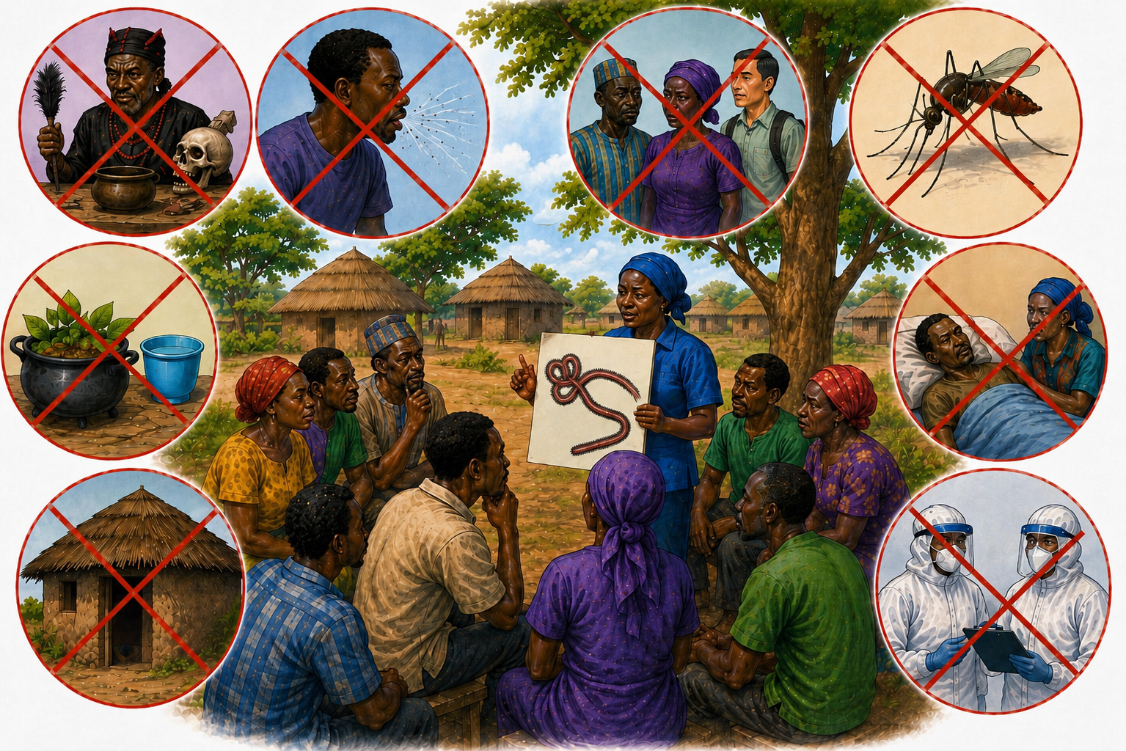

Presenter Notes: Myths and Rumors About Ebola
One of the biggest challenges during an Ebola outbreak is not just the disease itself—it is misinformation.
Point to each image as you discuss it.
Some people may believe that Ebola is caused by witchcraft or curses. Others may believe that certain home remedies, herbs, or special drinks can cure Ebola. Some people think that Ebola spreads through the air like a cold, that mosquitoes spread Ebola, or that only certain groups of people can become infected.
There are also times when people become afraid of health workers or believe that hospitals are dangerous. Because of these fears, some families may hide a sick person instead of seeking help.
Ask the group:
"Have you ever heard any rumors about Ebola or other diseases?"
Allow participants to share examples.
Explain:
Not everything we hear is true. During an outbreak, it is important to get information from trusted health authorities and trained health workers.

Presenter Notes – Managing Fear and Misinformation
Now discuss an important fact:
Most fevers are NOT Ebola.
Many illnesses begin with symptoms that look very similar. A person with Ebola may have fever, weakness, headache, vomiting, or diarrhea. But these same symptoms can also be caused by:
- Malaria
- Typhoid
- Influenza (flu)
- Other common illnesses
This means we should not assume that every person with a fever has Ebola.
At the same time, we should not ignore symptoms or hide illness. The safest response is to report concerns quickly and allow trained health workers to determine what care is needed.
Key Teaching Points
- Stay calm and encourage others to stay calm.
- Do not spread rumors.
- Do not hide sick people.
- Do not fear health workers.
- Remember that many illnesses can look like Ebola at first.
- Report illness early and follow the guidance of health authorities.
Closing Thought
Fear causes people to hide. Wisdom causes people to act.
When communities stay calm, report illness early, and work together with health workers, lives can be saved and outbreaks can be controlled much more quickly.

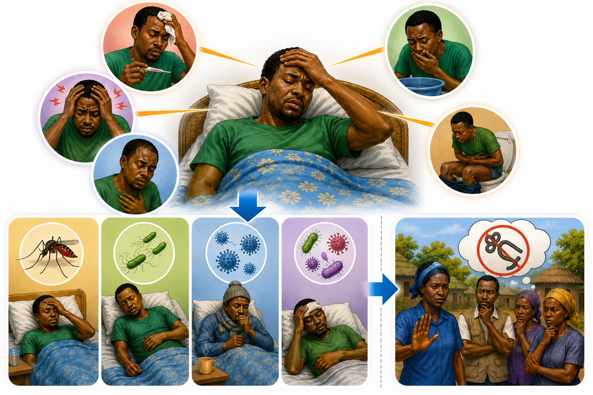
Flu
Cold
Typhoid
Malaria

Presenter Notes – Managing Fear and Misinformation
During an Ebola outbreak, fear can sometimes cause more problems than the disease itself.
Many Ebola outbreaks become worse because people are afraid. When people are afraid, rumors spread quickly. Communities may hide sick people, and some people become fearful of health workers who are trying to help.
Point to the first image.
Rumors can spread faster than facts. People may hear stories that are not true and begin making decisions based on fear instead of accurate information.
That’s why it is important to be educated on what to do, a part of our job is to help others understand the facts and avoid spreading rumors.
Point to the second image.
Sometimes families hide a sick person because they are afraid of what will happen. They may worry about stigma, isolation, or losing a loved one.
Although this fear is understandable, hiding illness can allow Ebola to spread to more family members and neighbors. Reporting illness early helps protect everyone.
Point to the third image.
Some communities become afraid of health workers, especially when they see protective clothing or hear stories about Ebola. But health workers are there to help. They are trained to care for sick people safely and to protect the community.
"Health workers are not the enemy. They are our partners in protecting lives."

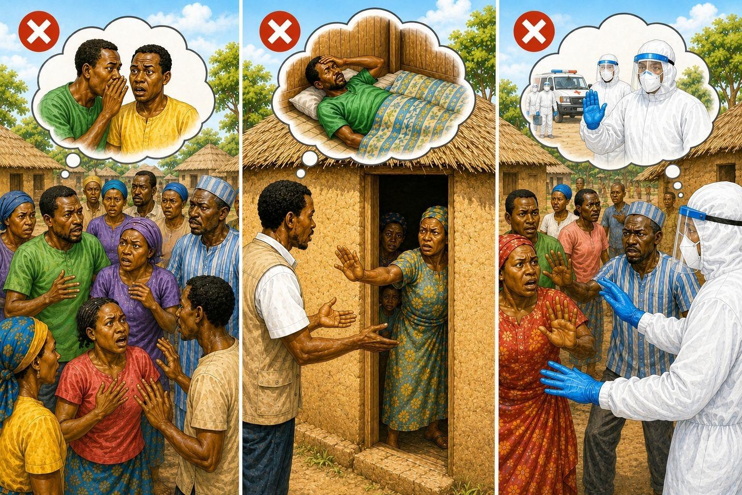

Presenter Notes – What to Do
Remind participants:
"People with Ebola are not our enemies. They are our neighbors, friends, and family members. We protect them and ourselves by following safety guidelines while continuing to show love and compassion."
Discussion Questions
Ask:
- Why is it important to stay calm during an outbreak?
- What are some ways we can help a sick person without touching them?
- How can we support a family whose loved one is being cared for by health workers?
Key Message
"Stay calm. Avoid direct contact. Notify health workers quickly. Keep others safe through separation. Continue to show kindness and compassion."

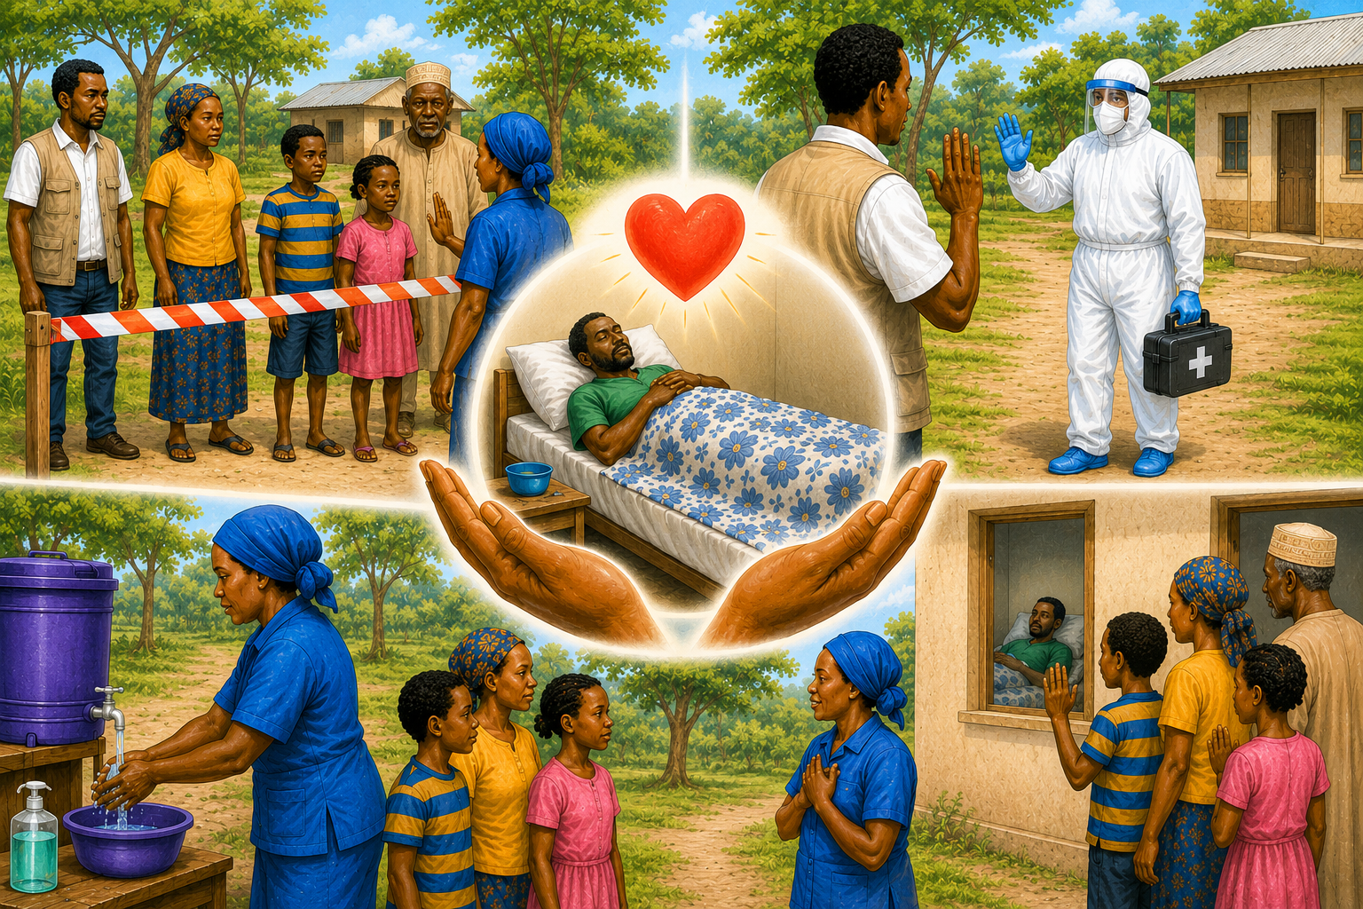

Presenter Notes – What to Do

When you see that someone is showing symptoms of Ebola here are the numbers that you can call:

Ministry of Health Hotline:
Nearby Health Facilities:
Local or Community Health Worker:
Field or Union Health Department Contact:
Other Important Contact:

Use this space to add:
Ministry of Health Hotline:
Nearby Health Facilities:
Local or Community Health Worker:
Field or Union Health Department Contact:
Other Important Contact:

If you see that someone is showing symptoms of Ebola, use these emergency numbers.

Presenter Notes – What to Do
Point to the first picture.
If someone in your family or community begins showing symptoms that could be Ebola, it is important to remember one thing first:
Stay calm.
Fear can cause people to make poor decisions. If we remain calm, we can help others remain calm by sharing accurate information and encouraging people to follow the guidance of health authorities.
Point to the next picture (top middle).
If a person is sick, avoid direct physical contact with them. Do not touch their blood, vomit, diarrhea, saliva, sweat, or other body fluids. Keep a safe distance and encourage others to do the same.
Point to the picture of contacting health workers.
Notify health workers or local health authorities immediately. Ebola is a medical emergency. The sooner trained health workers are informed, the sooner they can provide help and protect the community.
Point to the middle picture showing separation.
If possible, keep the sick person separated from others until trained health workers arrive. Limit the number of people who enter the area. Children, elderly people, and anyone who is not providing essential assistance should stay away.
Explain that separation is not punishment. It is a way of protecting family members and preventing the disease from spreading.
Point to the final picture showing support and compassion.
Even when we cannot have direct contact, we can still show kindness and compassion. We can speak encouraging words, pray with the person from a safe distance, provide information, help contact health workers, and support family members. And after the patient is cleared by medical professionals, we continue to show the same kindness. They can no longer spread the virus and there is nothing evil or wrong about them.

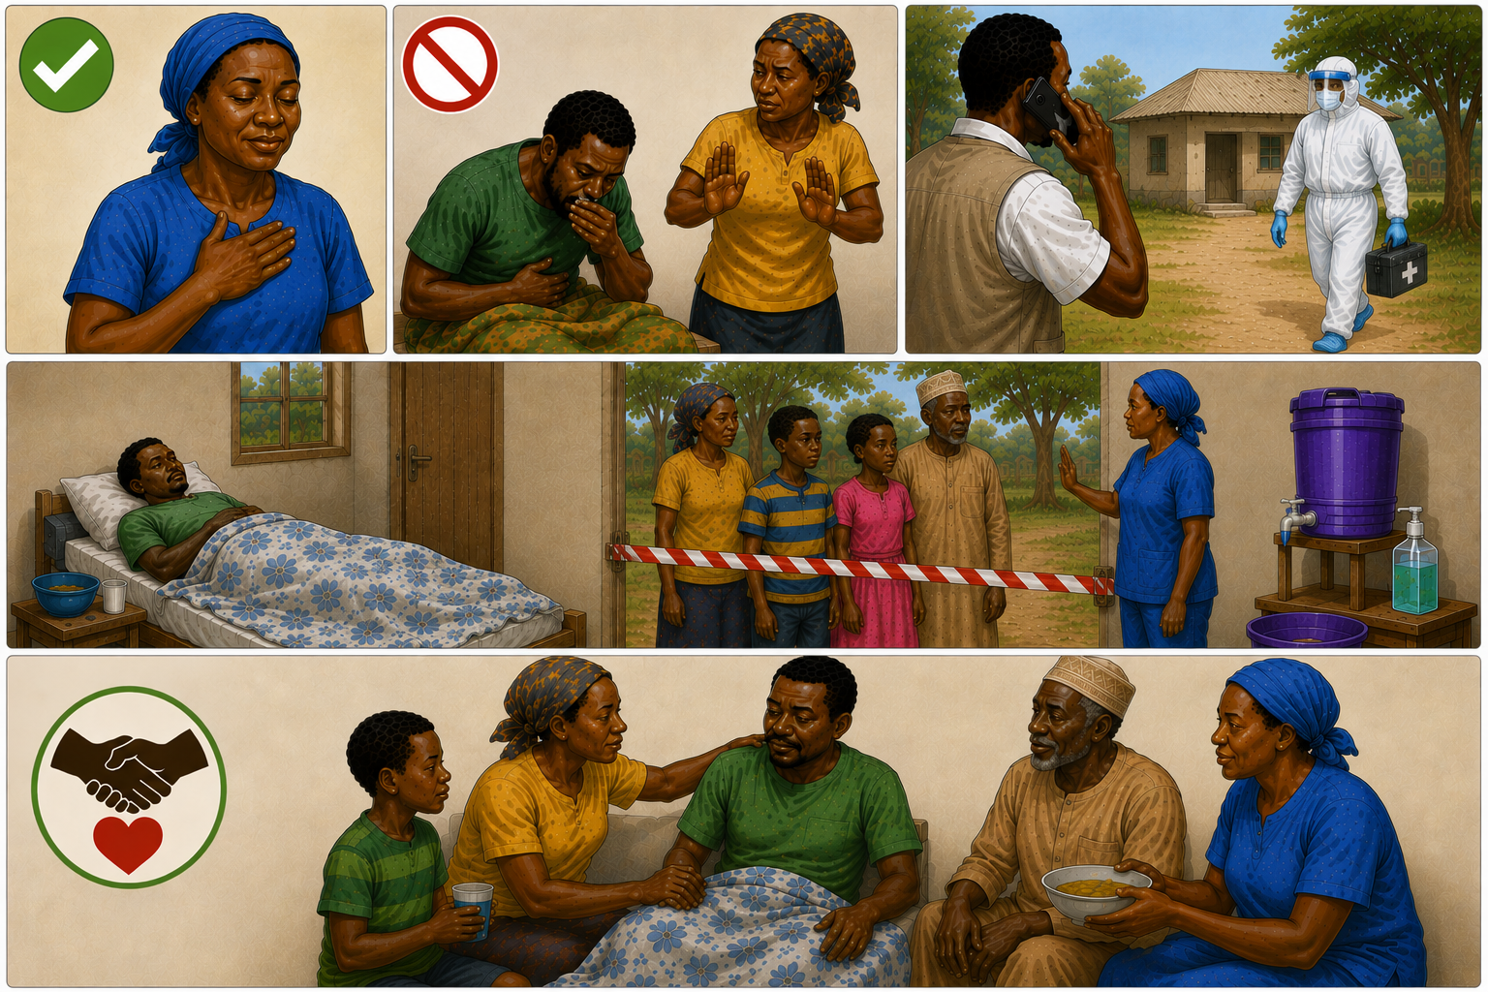

Demonstration Activity
Now let's practice proper handwashing together.
Demonstrate:
- Wet hands with clean water.
- Apply soap.
- Rub all surfaces of the hands, including between fingers and under nails.
- Scrub for at least 20 seconds.
- Rinse thoroughly with clean water.
- Allow hands to air dry or dry with a clean towel.
Ask participants to practice the steps and help one another remember the correct handwashing technique.
Conclude by reminding the group:
"Simple actions like handwashing, avoiding contact with body fluids, reporting illness early, and following health guidance can help protect our families and communities during an Ebola outbreak."

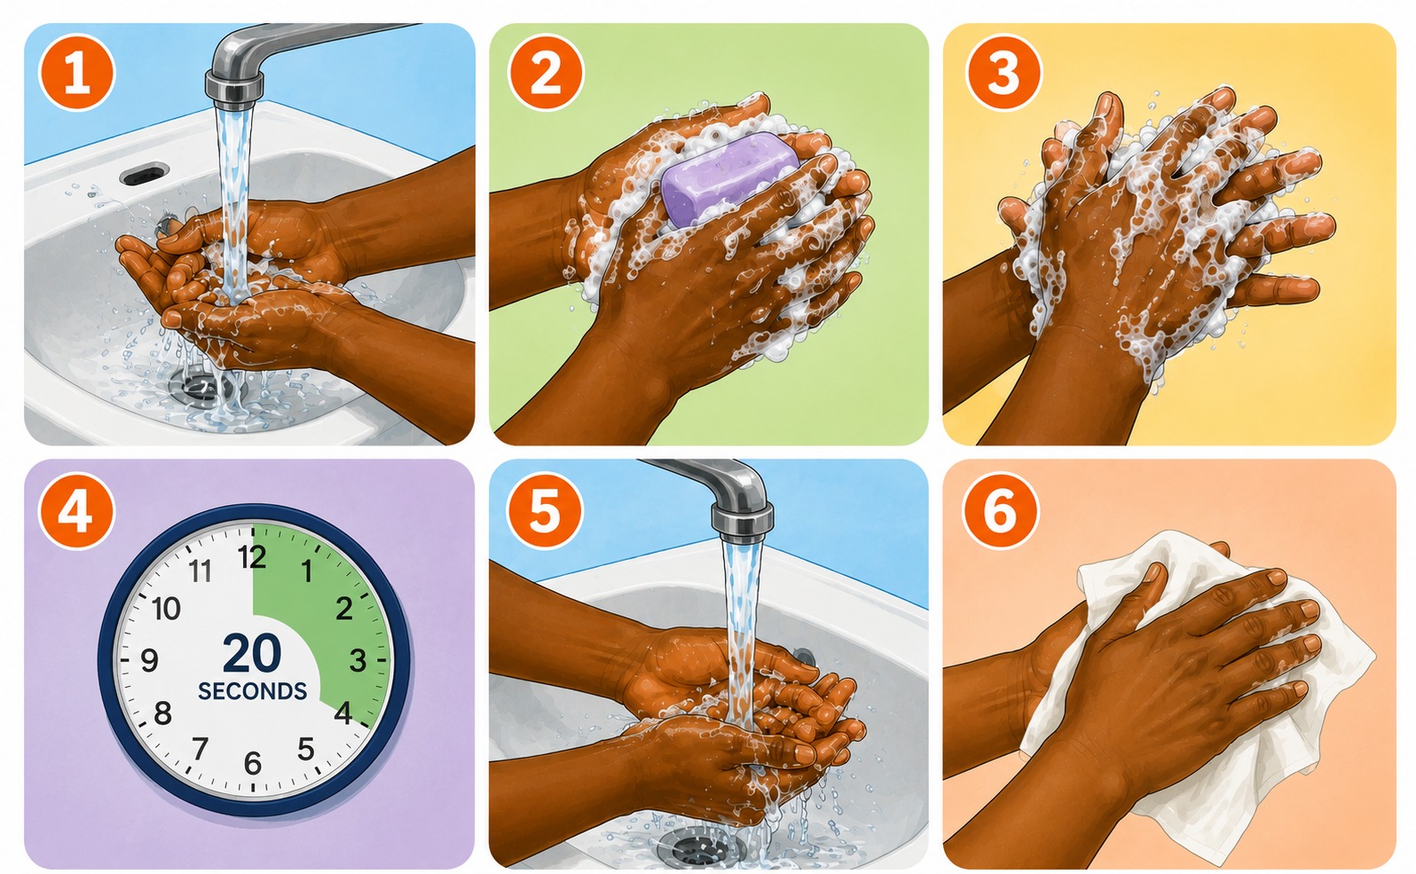

Presenter Notes - Prevention
Handwashing is one of the simplest and most effective ways to prevent the spread of Ebola and many other diseases.
Ask the group:
"When do you think it is important to wash your hands?"
Allow participants to share their ideas before reviewing the list together.
We should wash our hands:
- Before preparing food.
- Before eating.
- After using the toilet or latrine.
- After helping a child use the toilet or changing diapers.
- Before and after caring for someone who is sick.
- Before and after treating a cut or wound.
- After touching body fluids such as blood, vomit, diarrhea, or saliva.
- After coughing, sneezing, or blowing your nose.
- Whenever your hands are visibly dirty.
Explain that germs are often invisible. Our hands may look clean but can still carry germs that can make us or others sick.
During an Ebola outbreak, handwashing becomes even more important because it helps remove germs that may be picked up from surfaces, objects, or contact with other people.
Ask:
"Can you think of places in our community where handwashing stations would be helpful?"
Encourage discussion about homes, schools, churches, markets, health clinics, and community gathering places.
Conclude by saying:
"Every time we wash our hands, we are helping to protect ourselves and our community from disease."

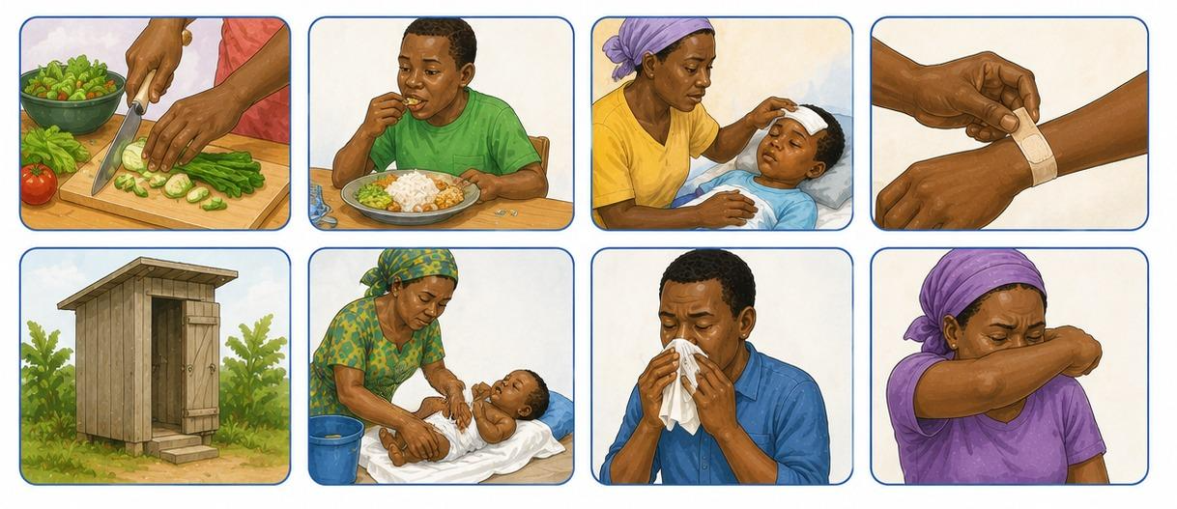

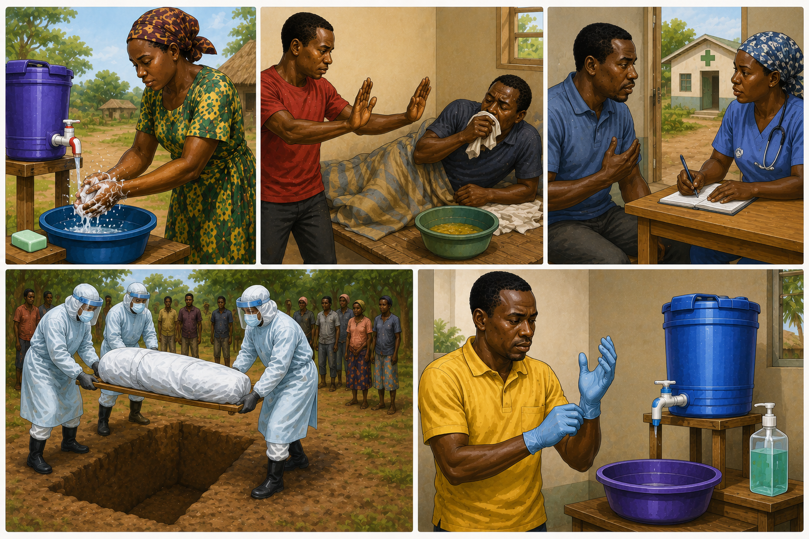

Presenter Notes - Prevention
Now that we understand how Ebola spreads, let's talk about how we can protect ourselves, our families, and our communities.
Point to the handwashing picture.
One of the best ways to prevent the spread of Ebola and many other diseases is to wash your hands often with soap and water. Wash your hands before preparing food, before eating, after using the toilet, after caring for someone who is sick, and whenever your hands may have come into contact with germs.
Point to the picture showing distance from a sick person.
If someone is showing symptoms of Ebola, avoid direct contact with them and their body fluids. Do not touch blood, vomit, diarrhea, saliva, sweat, or anything contaminated with these fluids. Encourage the person to seek professional medical help as soon as possible.
Point to the healthcare facility picture.
Early medical care saves lives. If someone is showing symptoms of Ebola, report the illness to local health authorities and help the person get medical care quickly. Do not try to diagnose or treat Ebola yourself.
Point to the safe burial picture.
People who have died from Ebola can still spread the disease. Never touch or prepare the body of someone who is suspected of having Ebola. Trained teams using proper protective equipment should handle burials.
Point to the gloves and handwashing station picture.
If gloves, masks, or other protective equipment are available, use them appropriately. Handwashing stations can help reduce the spread of disease in homes, churches, schools, and community gathering places.
Remind participants that these precautions are not meant to make us fearful. They are simple steps that help keep everyone safe while still allowing us to show kindness and compassion to those who are sick.

Presenter Notes – Signs and Symptoms
Now let's talk about the common symptoms of Ebola.
Point to each picture as you discuss it.
People with Ebola often develop a fever and may feel very weak or tired. They may also have a headache, muscle pain, vomiting, or diarrhea. Some people may experience bleeding, but this does not happen in every case.
It is important to remember that a person with Ebola is not contagious until they begin showing symptoms. Someone who has been exposed to Ebola but is not yet sick cannot spread the disease to others.
One challenge with Ebola is that the early symptoms can look very similar to other illnesses that are common in many communities. A person with Ebola may first appear to have malaria, typhoid, or another common sickness because they may only have a fever, headache, weakness, or stomach problems.
Because of this, we should not assume that every person with a fever has Ebola. At the same time, we should pay attention when someone has several symptoms together or has been in contact with a person who may have Ebola.
The goal is not to diagnose Ebola ourselves. Our job is to recognize the warning signs and encourage people to seek professional medical care quickly.
Point to the pictures again and review the symptoms:
Ask the group:
"Which of these symptoms have you seen before in people with malaria or typhoid?"
Allow discussion. Then remind participants that because these illnesses can look similar at first, it is important to report suspected cases and follow the guidance of health authorities.
Early medical care can save lives and help prevent the spread of Ebola.

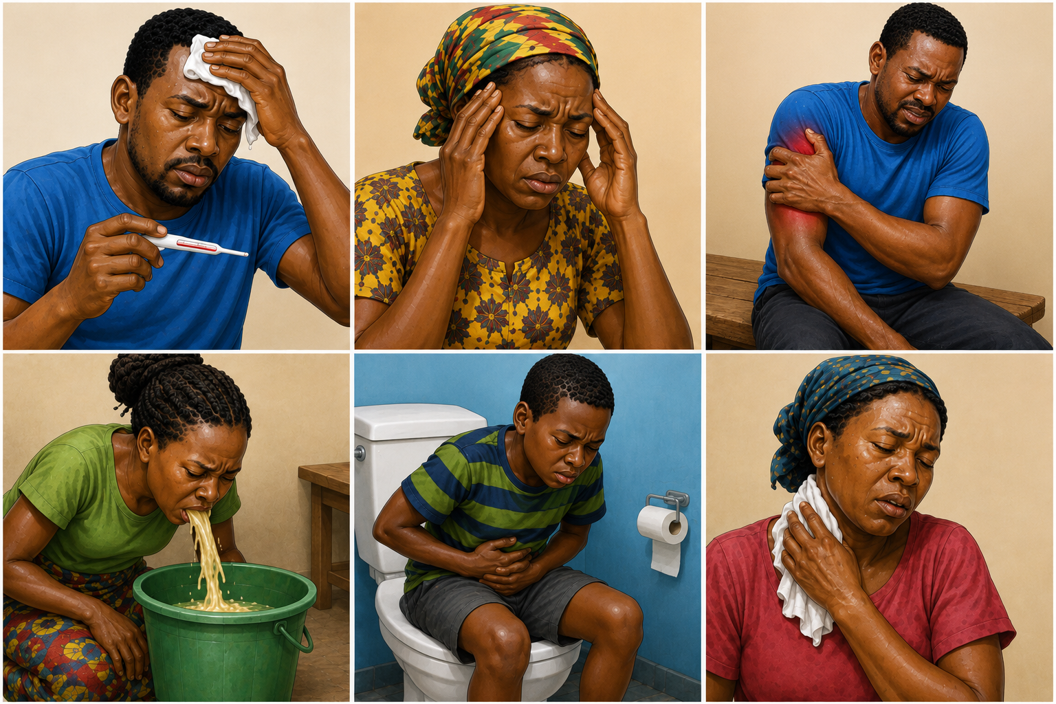
Vomiting
Sore Throat
Headache
Body
Aches
Diarrhea
Fever

Presenter Notes – How Ebola Spreads
One of the most important things to understand about Ebola is how it spreads.
Point to each picture as you discuss it.
Ebola spreads through the body fluids of a person who is sick. These body fluids include blood, vomit, diarrhea, sweat, saliva, and sexual fluids. A person can become infected if these fluids enter their eyes, nose, mouth, or an open cut on their skin.
Ebola can also spread when people touch or care for someone who is sick without proper protection. It can even spread through contact with the body of someone who has died from Ebola.
Because Ebola spreads through body fluids, it can move quickly through families and communities if people do not take precautions.
Now look at what is NOT shown in the pictures. Ebola does not spread simply because someone is nearby. You cannot get Ebola from talking with someone from a distance, walking past them, or breathing the same air.
Ebola is also not spread by mosquito bites.
This is important because many people become afraid during an outbreak. We want to share facts, not rumors. Understanding how Ebola spreads helps us take the right precautions without becoming fearful.
Ask the group:
"If Ebola spreads through body fluids, what are some ways we can protect ourselves and our families?"

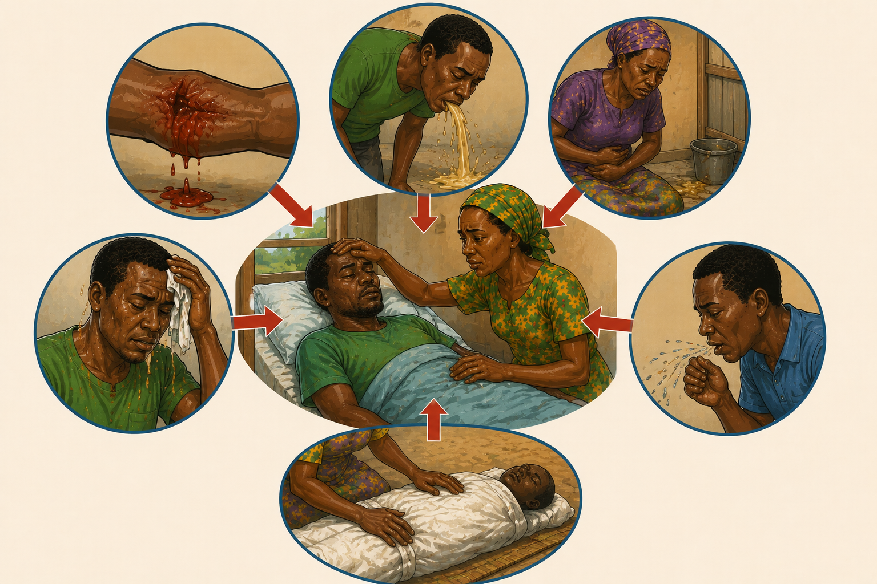
Cough Droplets
Contact with a dead body
Diarrhea
Sweat
Vomit
Blood

Presenter Notes – What is Ebola?
Today we are going to learn about Ebola. Ebola is a very serious sickness that can make people very ill. It is caused by a virus, which is a tiny germ that cannot be seen with our eyes.
Ebola is believed to originate in certain wild animals, especially fruit bats. Other wild animals, such as monkeys and apes, can also become infected. People can sometimes become infected when they hunt, handle, butcher, or eat infected wild animals.
Once Ebola infects a person, it can spread from one person to another through body fluids such as blood, vomit, diarrhea, saliva, sweat, and other fluids from a person who is sick. This is why Ebola can spread quickly if people are not careful.
The good news is that people can recover from Ebola, especially when they receive help and medical care early. That is why it is important to recognize the signs of Ebola and act quickly.

Point to the picture showing the spread of illness. Explain that direct contact with body fluids can pass the sickness from one person to another. Simply being near someone or talking to them does not spread Ebola.
Point to the picture showing the patient being taken to a health facility. Explain that getting medical help early gives a person the best chance to recover and helps protect others from becoming sick.
Point to the picture showing recovery and the healthy community. Remind participants that many people have survived Ebola. Our goal is not to be afraid, but to be informed and prepared.

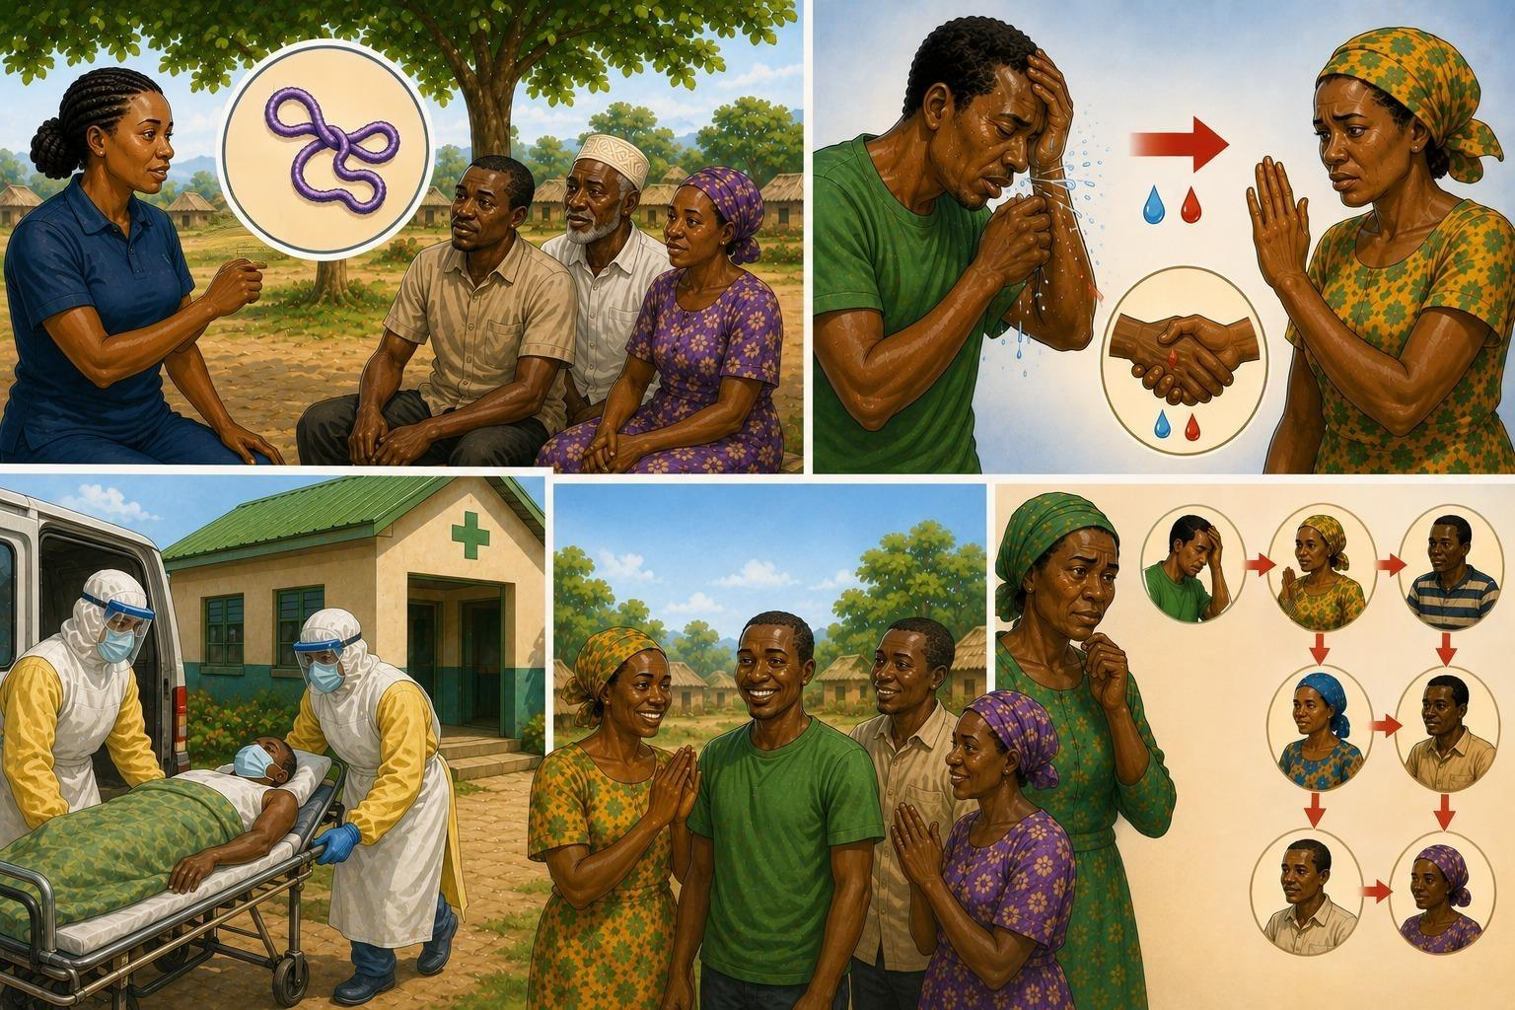

Presenter Notes - Introduction

Begin by introducing yourself to the group. Share a little about yourself, your family, and your connection to the community. You want the people in your class to see you as a friend and someone they can trust.
You may wish to share:
- Your name
- Information about your family
- How long you have lived in the community
- Why you enjoy helping others
Then explain that you have received training as a Healthy Heart worker and are there to help your community learn how to stay healthy and safe.
Let the group know that this class is designed to help them understand Ebola, recognize the symptoms, protect their families, and respond calmly and wisely if an outbreak occurs.
Encourage everyone to ask questions and participate in the discussion.
Ask:
“Have you heard of Ebola before?”
“What do you know or believe about it?”

